**Homework 1 – Comp 5710**

**Haden Stuart – has0027**



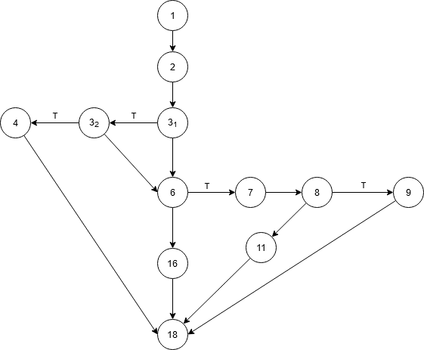

**Cyclomatic Number:**

1. |E| = 15; |V| = 12; V(G) = 15 – 12 + 2 = 5
2. Regions number = 4; V(G) = 4 + 1 = 5
3. Conditions number = 4; V(G) = 4 + 1 = 5

**P* = 1 + 2 * (1+2) = 7**



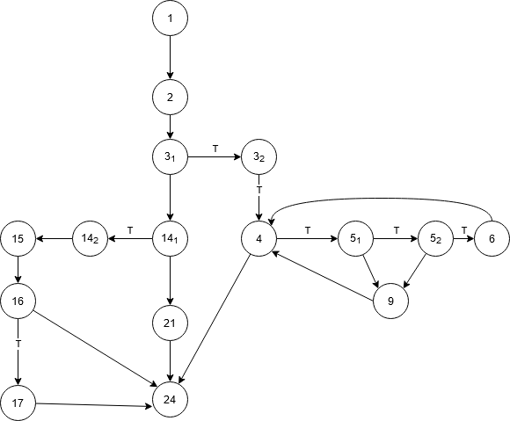

**Cyclomatic Number:**

1. |E| = 21; |V| = 16; V(G) = 21 – 16 + 2 = 7
2. Regions number = 6; V(G) = 6 + 1 = 7
3. Conditions number = 6; V(G) = 6 + 1 = 7

**P* = 3 + (23) = 11**



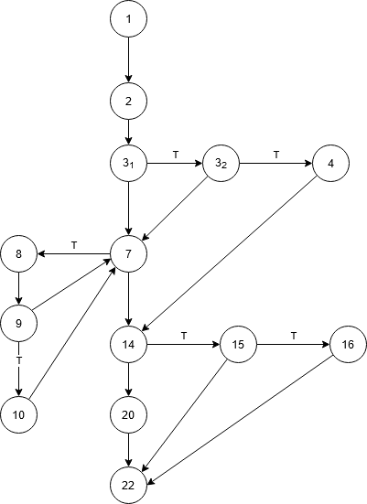

**Cyclomatic Number:**

1. |E| = 19; |V| = 14; V(G) = 19 – 14 + 2 = 7
2. Regions number = 6; V(G) = 6 + 1 = 7
3. Conditions number = 6; V(G) = 6 + 1 = 7

**P* = [3 + (20 + 21 + 22 + 23)] * [(23) + 1] = 17 * 9 = 153**



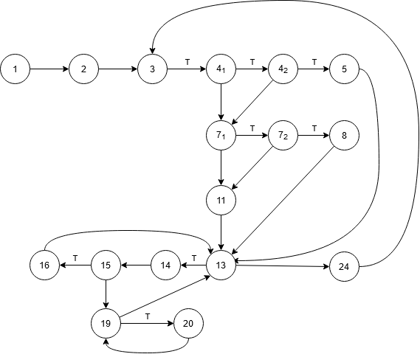

**Cyclomatic Number:**

1. |E| = 24; |V| = 17; V(G) = 24 – 17 + 2 = 9
2. Regions number = 6; V(G) = 8 + 1 = 9
3. Conditions number = 6; V(G) = 8 + 1 = 9

**P* = [5 * [1 + 13]2]2 = (5 * 4)2 = 400**